 | 26.2 Editors - Properties Editor - Render Properties Tab
Table of content
Detailed Table of content 1
Render Tab 3
Workbench - Performance panel 3
Sampling panel 3
Lighting panel 3
Color panel 4
Options panel 5
Simplify panel 7

Detailed Table of content

Detailed table of content
Detailed Table of content 1
Render Tab 3
Workbench - Performance panel 3
High Quality Normals 3
Sampling panel 3
Viewport Samples 3
Render 3
Viewport 3
Lighting panel 3
Flat 4
Studio 4
Light library browser 4
Rotation 4
User Preferences 4
Matcap 4
User Preferences 4
Flip Matcap 4
Color panel 4
Material 5
Object 5
Vertex 5
Single 5
Random 5
Texture 5
Options panel 5
X Ray 5
Backface Culling 5
Show X-Ray 5
X-Ray Alpha 5
Shadow 6
Shadow Intensity 6
Shading Shadow Options 6
Cavity 6
World 6
World Space / Ridge Valley 6
Shading Options 6
Screen 6
Screen Space / Ridge Valley 6
Both 6
Outline 6
Outline Color 6
Specular Lighting 7
Simplify panel 7
Enable 7
Viewport 7
Max Subdivisions 7
Max Child Particles 7
Volume Resolution 7
Render 7
Max Subdivisions 7
Max Child Particles 7
Grease Pencil 8
Playback Only 8
Fill 8
Modifiers 8
Shader Effects 8
Layers Tinting 8
Antialiasing 8

Render Tab

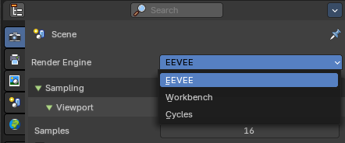
There are three different render engines available. Workbench, EEVEE, and Cycles. This chapter has a focus on the EEVEE render engine.

Workbench - Performance panel
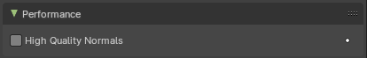

High Quality Normals
Use high quality tangent space. Slower but more accurate.

Sampling panel

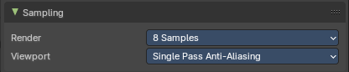
Viewport Samples
The number of samples when rendering in the viewport.

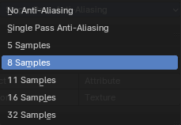
Render
The number of antialias samples when rendering to file.

Viewport
The number of antialias samples when rendering in viewport.

Lighting panel
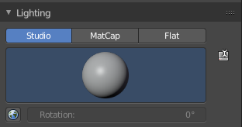
The Workbench renderer uses Open GL. OpenGL rendering is not influenced by the lights that you place in the workspace. But by a special OpenGL light setup. It can be tweaked in the Lighting panel and the User Preferences.

Flat
Use a flat lighting.

Studio
Use a Studio light setup.

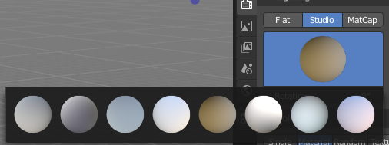
Light library browser
Choose a predefined studio light setup.

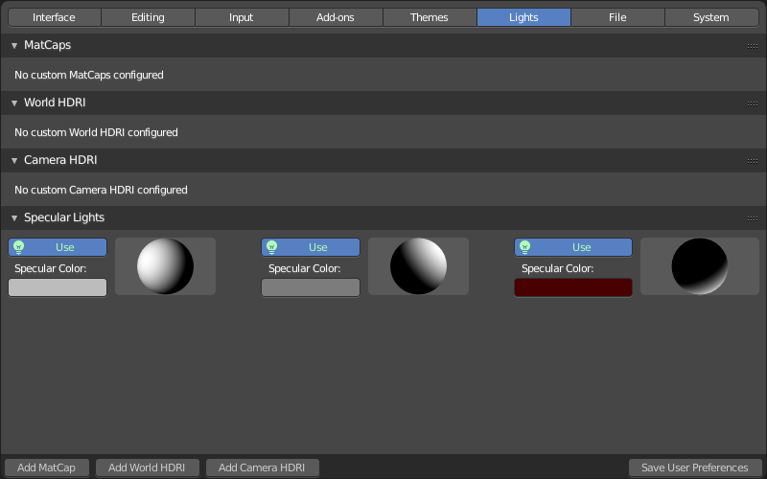
Rotation
Rotate the studio light setup.

User Preferences
A click at this button opens up the user preferences where you can add and manage the OpenGL Lights.

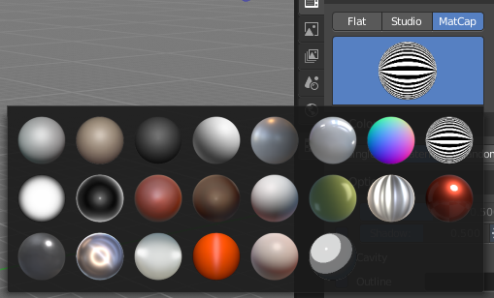
Matcap
Use Matcaps to render the scene.

User Preferences
A click at this button opens up the user preferences where you can add and manage the Matcaps.

Flip Matcap
Flips the matcap.

Color panel

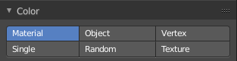
Workbench renderer is meant for fast preview display. It does not use materials like Eevee or Cycles. You choose a color instead.
This panel allows you to define the color of the surface of the object. This settings are also dependent of the chosen lighting.

Material
Uses the material including textures for the mesh.

Object
Uses the Object color.

Vertex
Uses the Vertex color.

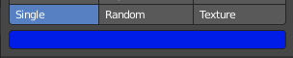
Single
Uses a single color for the selected mesh.

Random
Uses a random color for the mesh.

Texture
Renders the texture, and ignores the material settings.

Options panel
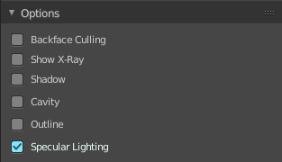

X Ray
Render the faces transparent.

Backface Culling
Don't calculate back faces.

Show X-Ray
Set X-Ray active, and adjust the amount of alpha that is used for the x-ray effect.
Note that you can have either X-Ray or Shadow and Cavity active. Not both at the same time.

X-Ray Alpha
This slider shows up when you tick Show X Ray. Adjust the intensity.

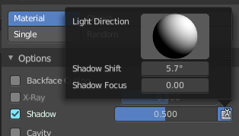
Shadow
Render Shadow.

Shadow Intensity
This slider shows up when you tick Shadow. Adjust the intensity.

Shading Shadow Options
Adjust a shadow shift relative to the light source.

Cavity
Show Cavity. Cavity highlights ridges and valleys in the scene geometry. Once activated Cavity shows some further settings.

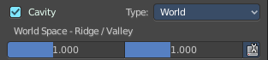
World
Draw the cavity shading in world space.

World Space / Ridge Valley
Factor for the cavity ridges and valleys.

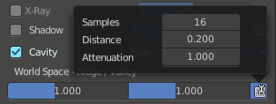
Shading Options
Adjust samples, distance and attenuation for the cavity ridges and valleys.

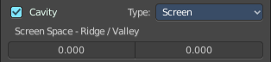
Screen
Draw the cavity shading in Screen space.

Screen Space / Ridge Valley
Factor for the curvature ridges and valleys.

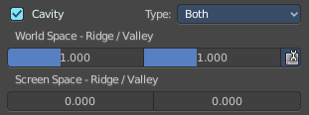
Both
Draw the cavity shading in both, World Space and Screen space.
Settings see above.

Outline
Show the not selected objects with an outline.

Outline Color
Define the color of the outline for not selected objects.

Specular Lighting
Render specular highlights.

Simplify panel

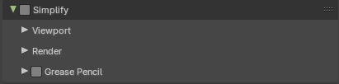
Sometimes you want to simplify the rendering without to loose the already tweaked settings and adjustments. For test renderings for example. Simplify allows you to set global limits on subdivision, shadow samples and more.

Enable
In the header is a checkbox to enable Simplify.

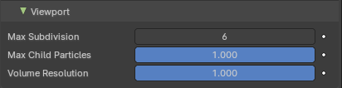
Viewport
This section affects the rendering with cycles in the Viewport.

Max Subdivisions
Limit the number of maximum subdivisions.

Max Child Particles
Limit the number of child particles

Volume Resolution
Simplify volumes by adjusting volume percentage of volume objects in viewport.

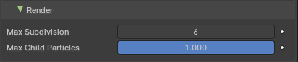
Render
This section affects the final rendering.

Max Subdivisions
Limit the number of maximum subdivisions.

Max Child Particles
Limit the number of child particles.

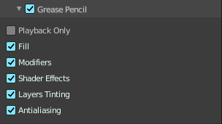
Grease Pencil

Playback Only
Simplify the grease pencil strokes only during playback.

Fill
Display Fill strokes in viewport.

Modifiers
Display Modifiers.

Shader Effects
Display Shader effects.

Layers Tinting
Display layer tint.

Antialiasing
Use antialiasing to smooth stroke edges.

